# Chapter 5: Implementation

This chapter will discuss implementation details supported by UML diagrams (if applicable). You will not put your source code here. Any of the following sections may be included based on your project.

# User Interface

**Sign-up**

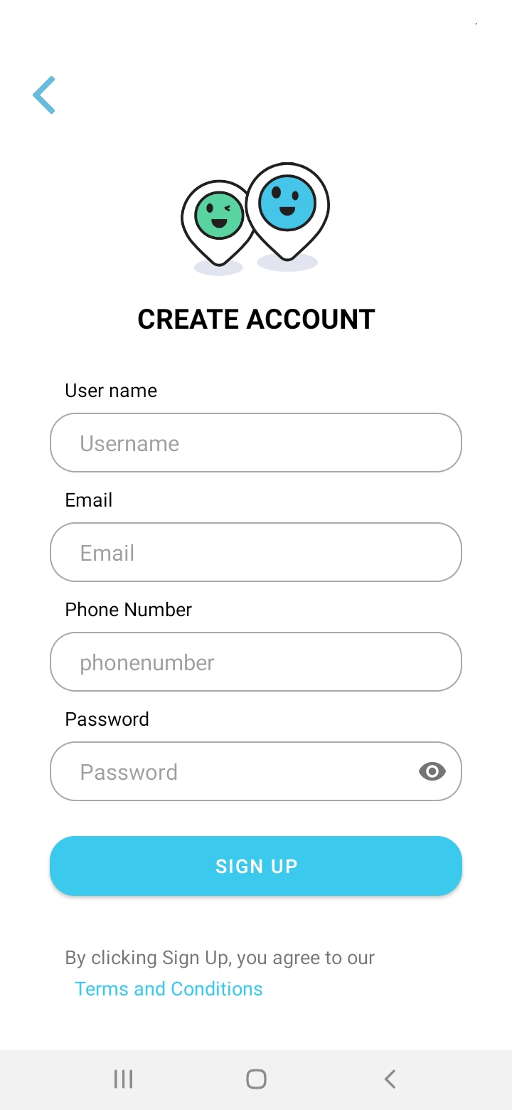

**Profile Screen**

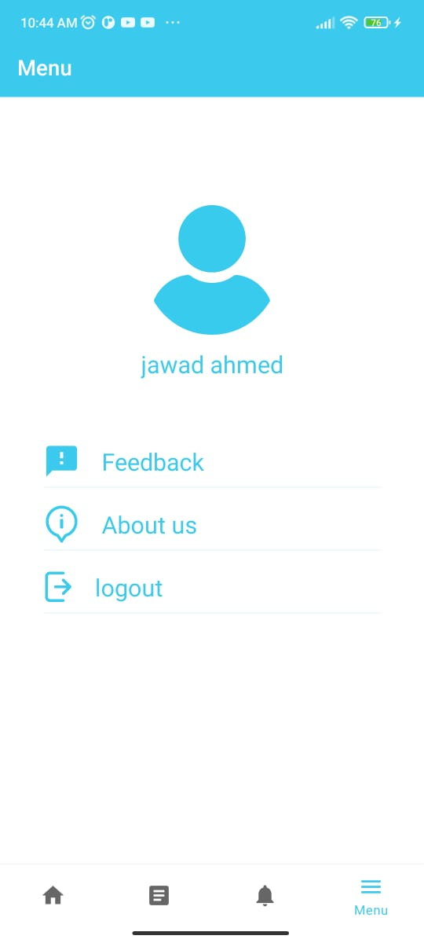

**Decide User Screen**

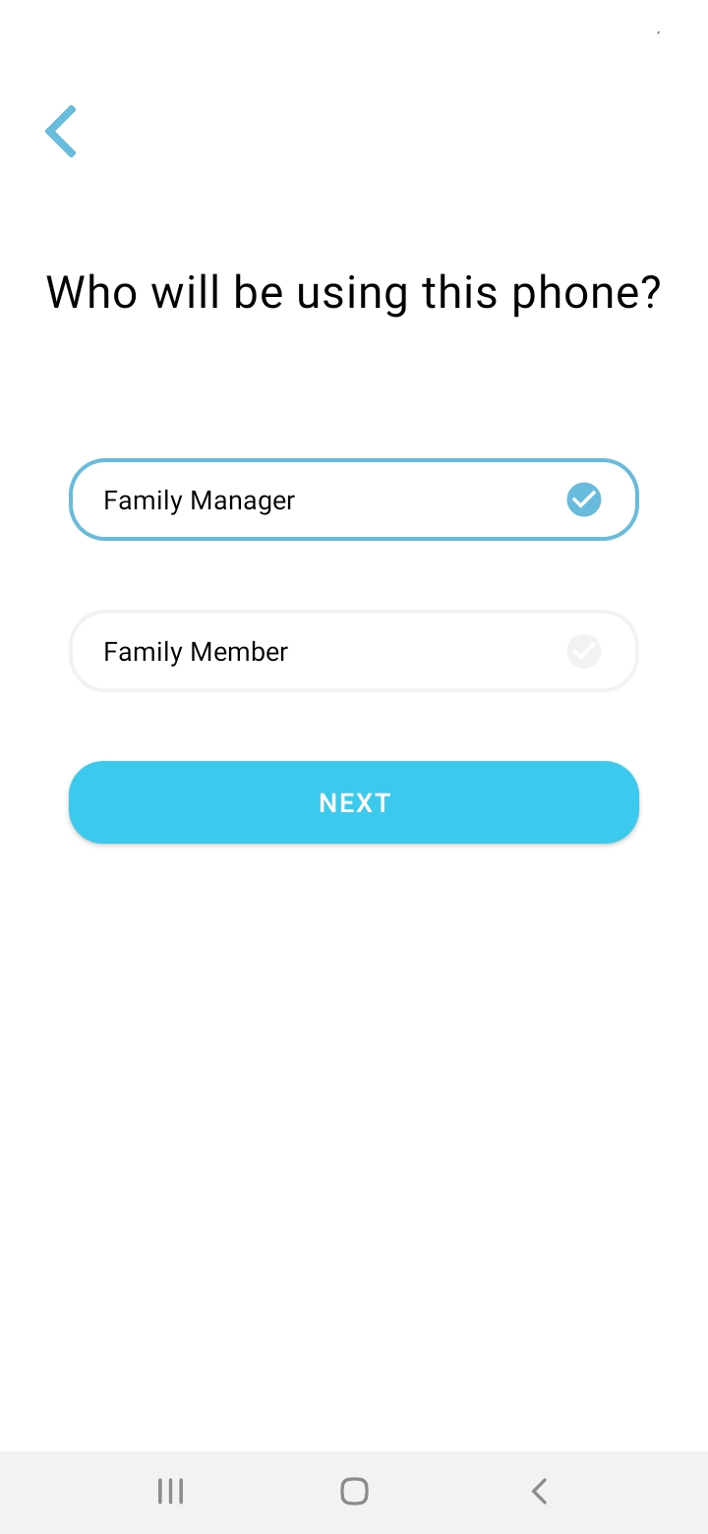

**Location History**

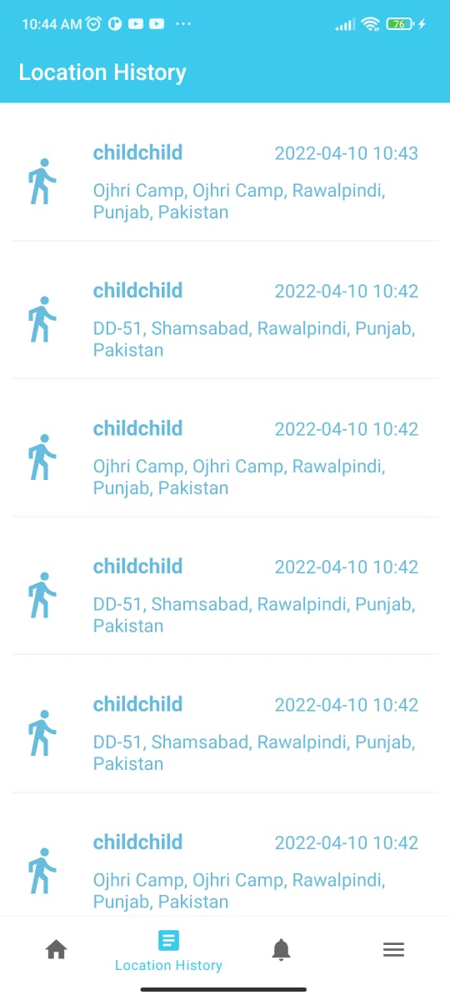

**Code Generation Screen**

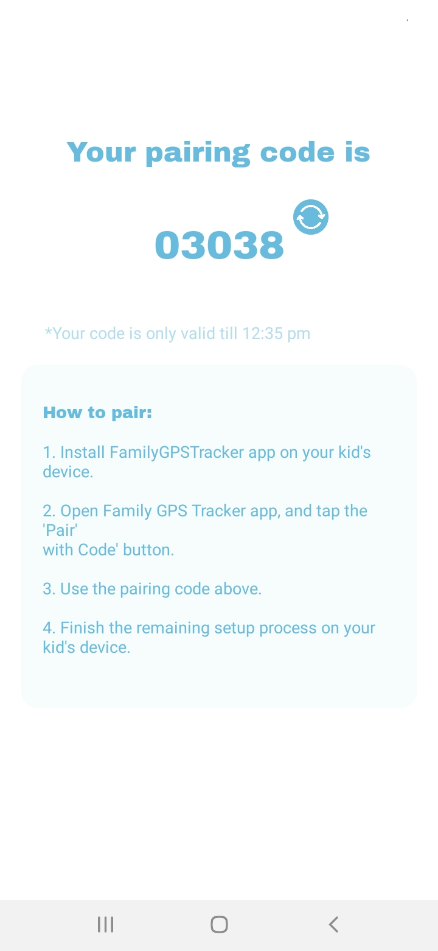

**Sign In**



**Device Connecting Screen**

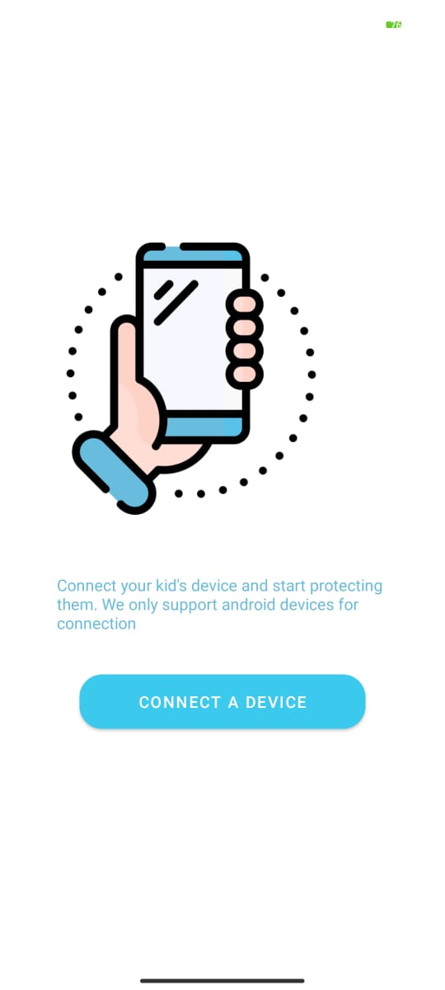

**Home Screen**

